John McCormack  
Assignment #2  
2/17/2015

histogram.py

This program opens four copies of the same image, each with a slightly different edit to it. It then computes the CDF of each image, and normalizes the image based on this. The system works perfectly for the Low Contrast, Dark, and Bright images. On the High contrast image, the histogram has trouble correcting the skyline of the image. This may be an issue with using Gimp, as the image itself seems distorted after increasing the contrast. The CDFs are all plotted on the same graph. Each of the histograms are also independently graphed along with their CDFs in separate files.

The original image is:

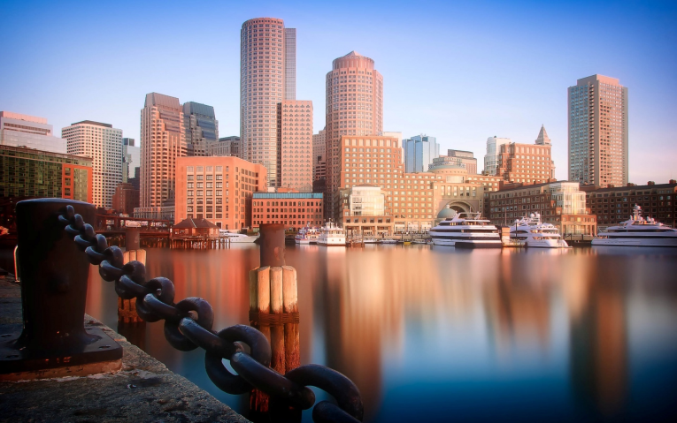

Low Contrast:



High Contrast:

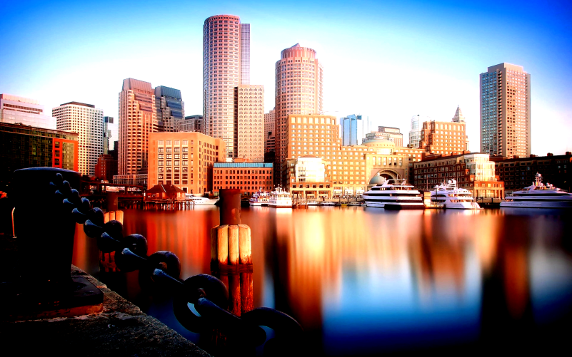

Dark:



Bright:



Output Image:

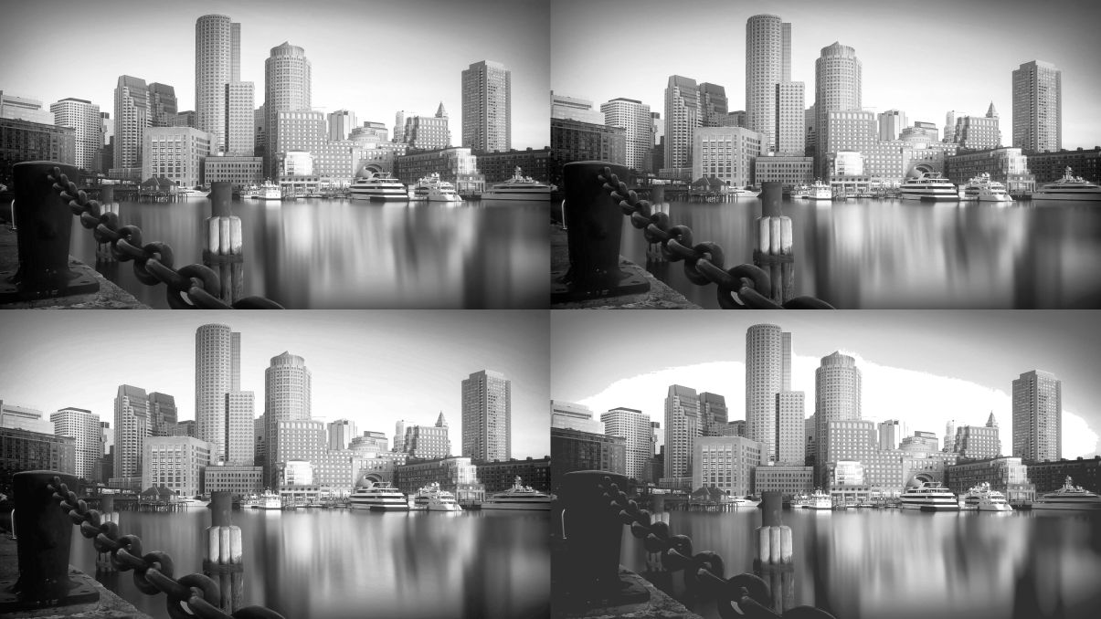

Top Right: Bright  
Top Left: Dark  
Bottom Right: Low Contrast  
Bottom Left: High Contrast

CDFs of all functions:

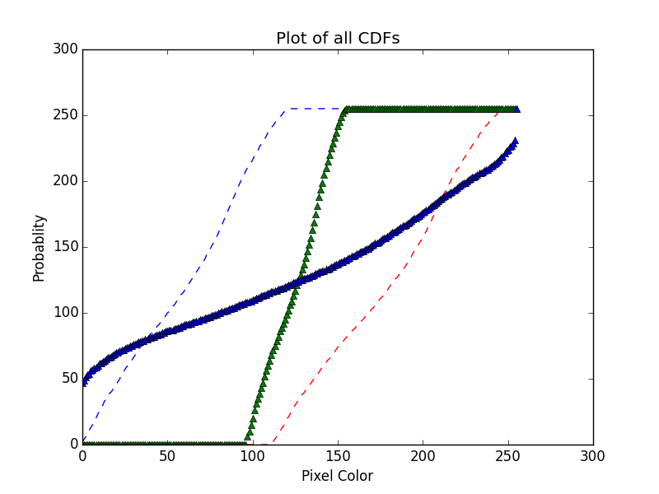

Green Triangle = High Contrast  
Blue Triangle = Low Contrast  
Blue Dash = Dark  
Red Dash = Bright